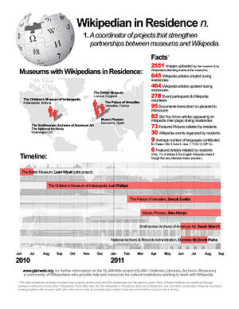

We are seeking applications for a Wikimedian in Residence from outgoing and committed individuals with excellent presentation and organising skills to work at National Library of Scotland for a period of 4 months.

The following range of knowledge, skills and experience are required. Please ensure these are reflected in your application. Short listing for interview will be based on meeting these requirements.

- have the ability to teach and support those learning to use Wikipedia and its sister websites, including organising events and workshops
- good verbal and written communication skills
- communicate in English clearly to a wide variety of audiences and have excellent presentation skills
- have an understanding of and empathy for Wikimedia UK's mission to help people and organisations build and preserve open knowledge to share and use freely
- ideally be an experienced Wikimedian
- have experience of organising meetings and experience of coordinating and leading workshops or similar
- be familiar with office IT packages
- be familiar with libraries or the cultural heritage sector
- be flexible and adaptable
- commit to the hours required for the duration of the Residency

What you will do

Help the Library explore how its collections and knowledge can be used to broaden content on Wikipedia and sister projects. You will also undertake outreach work to encourage understanding and development of Wikimedia projects.

- work with staff, including librarians and curators, to identify areas of Wikipedia and sister projects that could be enriched with resources and knowledge from the Library’s collections
- organise and host workshops for Library staff to explain how they can directly contribute their knowledge and expertise to develop Wikipedia articles
- explore adding digital resources such as our digitised books, articles, photographs and posters to Wikimedia Commons
- provide training and best-practice guidance on Wikimedia editing and Wikimedia volunteer engagement
- help the Library develop an outreach policy to coordinate contributions from the wider Scottish community to develop Wikipedia in under-represented areas
- help establish relationships with the Scottish Wikimedia community, editors and projects
- help organise and host other Wikimedia related events for members of the public, Wikimedians, researchers and librarians such as workshops, Edit-athons, meetups, backstage pass tours
- produce on-going updates and a summary report on the outcomes of the residency

Who will I work with?

You will work with a small team who will support you in your Residency and program of work. You will also work with colleagues in the Library including librarians and curators. You may work with people in other libraries and cultural organisations and Wikimedia UK.

Where will I work?

You will be based at National Library of Scotland in central Edinburgh. There may be flexibility to allow you to work from home on occasion. You may be expected to travel to meetings or to host events in other parts of Scotland.

To apply
Please complete the application form at http://www.nls.engageats.co.uk/Welcome.aspx;

- attach your CV
- a statement on why you would like to be the Wikimedian in Residence at National Library of Scotland including:
- your Wikimedia username if applicable
- an outline of your experience as a Wikimedia editor
- an overview of your experience coordination and leading workshops/events
- any supporting evidence you think would be helpful to your application

Salary for the Fixed Term post is £30,000 per annum pro rata. The salary is jointly funded by Wikimedia and National Library of Scotland.

More information
If you would like more information about the post please email or phone:
Gill Hamilton
Digital Access Manager, National Library of Scotland
g.hamilton@nls.uk +44 (0)131 623 3770

National Library of Scotland http://www.nls.uk/

Wikimedia UK http://uk.wikimedia.org/wiki/Main_Page

Wikimedian in Residence http://outreach.wikimedia.org/wiki/Wikipedian in_Residence

NLS recruitment http://www.nls.engageats.co.uk/Welcome.aspx;

The closing date for completed applications is Monday 6th May 2013.

Please note that the successful candidate will be subject to Basic Disclosure Scotland security clearance.

