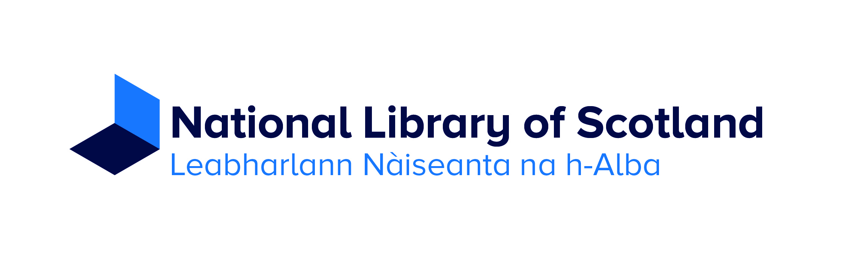
Cross Trust Special Collections Internships at the National Library of Scotland
Thanks to the generous support of the Cross Trust, The National Library of Scotland is offering two four-week internships working with special collections to begin in late July 2018.
The internships are aimed at people preparing for a career in rare book librarianship, or archives and records management, and offer the opportunity to spend a month working with the National Library of Scotland’s special collections, carrying out a programme of practical tasks relating to collection management, resource discovery and digitisation. Curators from Rare Books and Archives and Manuscript Collections will act as mentors throughout the internships, and on a day to day basis the interns will work with colleagues in a number of different areas of the Library, including the Collections Care, Digital, and Special Collections Reading Room teams.
Besides learning about the work involved in the collection management and digitisation of special collections, and in running a special collections reading room and other public services, the interns will gain experience handling a large number and variety of rare books, and in fundamental descriptive processes to make accessible archive and manuscript collections. There will also be a programme of induction sessions with curatorial teams and other areas of the Library.
Specific training and work-based activities for the internships will include:
- Assisting with the Library’s programme of auditing special collections
- Assisting the Special Collections Reading Room team with public services relating to the rare book and archive and manuscript collections
- Creating, updating and editing finding aids for archive and manuscript collections
- Digitisation preparation and metadata work
- Collections management activities
- Opportunities to contribute to Library social media
The interns will receive a grant of £1250.
Personal specification
The internships are primarily aimed at applicants who are either currently enrolled in or within a year of completing a programme leading to a qualification in professional librarianship at undergraduate or postgraduate level, or a postgraduate qualification in archives and records management, or intending to apply for a programme at postgraduate level in the near future. No previous experience working with special collections is required.
The requirements of the funding from the Cross Trust are for the interns to be under 30 years old on 24 August 2018 and to be of Scottish birth or parentage (i.e. born in Scotland or with at least one parent born in Scotland).
To apply please go to the National Library of Scotland’s recruitment site:
http://www.nls.engageats.co.uk/Welcome.aspx to submit your application.
We will require a supporting statement explaining why you are interested in this opportunity

Please upload:
- Your CV
- proof that you will be under 30 years old on 24 August 2018 and that you or one of your parents were born in Scotland, in the form of a scanned birth certificate or similar in the additional documents tab.

If you have any questions about the internships please contact James Mitchell james.mitchell@nls.uk
If you have any problems completing your application please email jobs@nls.uk

